Single Molecule Techniques Can Distinguish the Photophysical Processes Governing Metal-Enhanced Fluorescence
Gregory K. Hodgson, Nicholas P. Dogantzis and Stefania Impellizzeri*
AUTHOR ADDRESS
Laboratory for Nanomaterials and Molecular Plasmonics, Department of Chemistry and Biology, Ryerson University, 350 Victoria St., Toronto, ON, M5B 2K3, Canada.
AUTHOR INFORMATION
Corresponding Author
*Stefania Impellizzeri
Email: simpellizzeri@ryerson.ca
ABSTRACT
Plasmonic metal nanoparticles can impact the behaviour of organic molecules in a number of ways, including enhancing or quenching fluorescence. Only through a comprehensive understanding of the fundamental photophysical processes regulating nano-molecular interactions can these effects be controlled, and exploited to the fullest extent possible. Metal-enhanced fluorescence (MEF) is governed by two underlying processes, increased rate of fluorophore excitation and increased fluorophore emission, the balance between which has implications for optimizing hybrid nanoparticle-molecular systems for various applications. We report groundbreaking work on the use of single molecule fluorescence microscopy to distinguish between the two mechanistic components of MEF, in a model system consisting of two analogous boron dipyrromethene (BODIPY) fluorophores and triangular silver nanoparticles (AgNP). We demonstrate that the increased excitation MEF mechanism occurs to approximately the same extent for both dyes, but that the BODIPY with the higher quantum yield of fluorescence experiences a greater degree of MEF via the increased fluorophore emission mechanism, and higher overall enhancement, as a result of its superior ability to undergo near-field interactions with AgNP. We foresee that this knowledge and methodology will be used to tailor MEF to meet the needs of different applications, such as those requiring maximum enhancement of fluorescence intensity or instead prioritizing excited-state photochemistry.
KEYWORDS Fluorescence enhancement, silver nanoparticles, plasmonics, fluorescence microscopy, boron dipyrromethene, BODIPY
INTRODUCTION
Applications abound for the activation, manipulation and magnification of molecular fluorescence, such as bioimaging, clinical diagnostics, sensing, information security, patterning, optoelectronics, catalysis and single molecule tracking.^{1–19} Merging modern physical organic chemistry with nanomaterials science is pushing boundaries in many of these areas, where fusion between the study of fundamental photophysical processes and nanoparticle-molecular interactions is rapidly expanding the scientific body of knowledge, producing remarkable developments on an almost daily basis.^{20–29} Optimization of these advances, tailored to the requirements of different applications, rests upon the ability to elucidate the underlying mechanisms involved.
We recently reported a hybrid nano-molecular system for applications of fluorescence activation in solution and in thin polymer films.³⁰ In brief, the highly quenched emission of boron dipyrromethene (BODIPY) species 1 can be turned on by optically stimulating a ligand exchange around the boron centre using either UVA- or UVC-activated photoacid generators (PAGs) to form species 2 (Chart 1). We further established that triangular silver nanoparticles (AgNP) with 104 ± 28 nm edge length (Figure S1) dramatically increase the steady-state fluorescence intensities of 1 and 2 through metal-enhanced fluorescence (MEF) in thin films. Intrigued by the preliminary results we obtained by monitoring the transformation of 1 into 2, we elected to perform a deeper investigation into the photophysical processes governing MEF. In particular, we became interested in the possibility of using single molecule techniques to distinguish and compare the MEF of 1 and 2 from a mechanistic standpoint, in an effort to gain insight into the nano-molecular interactions involved. Whereas our previous research focused on applications of fluorescence activation, the motivation for the current work is to study MEF from a more fundamental perspective. In this contribution, we describe the MEF of 1 and 2 at the single molecule level separately, arriving at the first iteration of a method for using Total Internal Reflection Fluorescence Microscopy (TIRFM) to estimate the relative contributions of the two known MEF mechanisms for each dye.

Chart 1. Chemical structures of BODIPY dyes 1 and 2 synthesized and studied separately at the single molecule level.
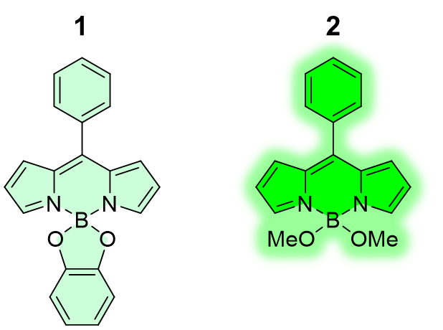
The MEF phenomenon has been the subject of intense research over the last two decades, including extensive work by the independent research groups of Lakowicz and Geddes, and many excellent reviews cover the associated theory in detail.^{9,10,23,31–43} It is our intent to make this topic as accessible as possible in order to facilitate more effective application of MEF across interdisciplinary research. To briefly summarize this body of research, it is now generally agreed that MEF arises from near-field nano-molecular interactions that enhance brightness by increasing either the rate of fluorophore excitation or the radiative decay rate, or both.^{9,10,23,31–45} Specifically, the surface plasmons of metal nanoparticles (NP) concentrate the electric field in proximity to the NP surface, increasing the probability of fluorophore excitation. In parallel, the effective quantum yield of fluorescence may also be increased through the formation of a radiative NP-fluorophore complex (referred to as a ‘plasmophore’), which exhibits a characteristically higher radiative decay rate and lower fluorescence lifetime relative to organic fluorophores alone (Figure 1).^{9,42} Alternatively, this type of enhancement could be considered from the perspective of the fluorophore alone, and described as molecular emission enhanced by the electromagnetic field generated by plasmonic excitation of AgNP. For some dye-NP combinations, reports of blue- and/or red-edge spectral distortions have been explained by modification of the density of states in radiative transitions linked to the plasmophoric MEF mechanism.²³ In such cases, ultrafast NP-dye coupling to higher vibrational states in the S₁ vibrational manifold, occurring faster than internal conversion, can violate Kasha’s rule and cause blue-shifted emission. Similarly, enhancement of the radiative decay rate can cause red-edge distortions by increasing the probability of radiative transitions from S₁(0) to non-zero vibrational levels in the ground electronic state.²³ In contrast, increased excitation MEF is not expected to significantly modify the Boltzmann distribution, and the spectral profile of enhanced emission should be nearly indistinguishable from that of fluorescence emission in free space.^{23,42} While it is clear that the photophysical properties of the dye and their spectral relationship to the metal NP play a role in this narrative (e.g. extent of overlap between fluorophore emission and NP extinction), other effects such as stabilization or destabilization of uncoupled, excited state fluorophores by an appropriately oriented dipole of excited plasmons affecting local solvent polarity may also play a role and a general relationship has yet to be fully elucidated.²³ Figure 1 provides a general illustration of the two MEF mechanisms for cases in which Kasha’s rule is maintained and spectral distortions are negligible.

Increased Excitation
Increased
Φ_{F}
Classical
MEF
Φ_{F}
Excitation
Figure 1. Metal nanoparticles may enhance fluorescence intensity relative to classical emission in free space, by increasing the rate of fluorophore excitation or by increasing the effective quantum yield through the formation of plasmophores.

As shown in eqs 1 and 2, the common manipulation of non-radiative decay pathways causes a proportional increase or decrease in both the quantum yield of fluorescence (Φ_{F}) and the fluorescence lifetime (τ).^{9,10,42,45}
$$Φ_{F}=\frac{Γ}{Γ+k_{nr}}$$
(1)
$$τ=\frac{1}{Γ+k_{nr}}$$
(2)
Where Γ represents the radiative decay rate for the organic dye, and k_{nr} is the combined rate constant for all non-radiative decay pathways. In contrast, dye-NP coupling involved in the plasmophoric MEF mechanism requires the introduction of a term representing the radiative decay rate of plasmonic metal nanoparticles (Γ_{NP}). Interestingly, this can cause Φ_{F} and τ to move in opposite directions (eqs 3 and 4).^{9,10,42,45}
$$Φ_{F}=\frac{Γ+Γ_{NP}}{Γ+Γ_{NP}+k_{nr}}$$
(3)
$$τ=\frac{1}{Γ+Γ_{NP}+k_{nr}}$$
(4)
Much of the relevant literature acknowledges the effects of NP size, shape, orientation, interparticle spacing or dye-NP separation upon ensemble averaged fluorescence enhancement factors.^{5,6,9,27,29,32,36,42–48} However, the importance of the optical properties of all the different components of the system (NP and dyes working synergistically) has indeed been investigated, but is not as widely understood. For instance, the common generalization that larger NP are better for MEF can be misleading because it fails to convey the importance of the excitation source and spectral properties of the fluorophore. While it is true that the scattering component of the extinction spectrum tends to be greater for larger NP of the same shape, it is the overlap between the emission spectrum of the dye and the NP scattering that is essential for MEF (spectral overlap with NP absorption quenches fluorescence).^{9,22,29,31,32,41,42,49} It is also possible that the extinction spectrum of nanoscale polyhedra may contain a greater scattering component than that of relatively larger spherical NP, or simply scatter over a range of wavelengths that is more convenient for achieving MEF using a given dye and excitation wavelength combination.
The importance of spectral overlap between the absorption of the dye and NP scattering is sometimes overstated as well, likely because the dye’s absorption profile obviously influences the selection of excitation wavelength. The underlying requirement for MEF is actually the activation of surface plasmons, which can indeed be accomplished using the same far-field irradiation used to excite the organic dye. However, it is also theoretically possible for surface plasmons to be excited by the emission of nearby fluorophores,^{9,11,42} and at least one experimental study has provided irrefutable evidence that MEF can be achieved in this way.⁵⁰
While recent research efforts have concentrated on predicting enhancement factors, MEF-induced spectral distortions and the impact of far-field irradiance, very little attention has been paid to investigating the balance between the two MEF mechanisms.^{23–25,32} Distinguishing between the two MEF mechanisms at the bench scale is prohibited by the need to measure the modified molecular extinction coefficient and quantum yield of fluorescence in the presence of NP.⁴⁵ This is difficult to do reliably because AgNP also enhance the excitation light, and also because molecular absorption may overlap with NP extinction. Such steady-state measurements are further complicated for thin films, where the extinction coefficient and quantum yield of fluorescence are not easily obtained even in the absence of NP. In fact, we are only aware of a single experimental study in the present literature, in which a single molecule level investigation of MEF as a function of gold NP size and interparticle spacing included the elegant use of fluorescence lifetime imaging (FLIM) to facilitate a semi-quantitative discussion of the relative enhancement factors attributable to an increased rate of radiative decay or fluorophore excitation.⁴⁵ Unfortunately, the inherently short fluorescence lifetimes of low quantum yield fluorophores can render any lifetime decrease caused by dye-NP coupling in the plasmophoric MEF mechanism beyond the limit of detection for most benchtop, steady-state fluorescence lifetime instruments and all but the most sensitive, picosecond-responsive FLIM or laser flash photolysis systems. This is especially true for BODIPYs lacking steric hindrance to rotation at the 5-aryl substituent position,⁵¹ such as 1 and 2 of interest here (lifetime measured at < 1 ns in the absence of AgNP). It is therefore worthwhile to develop a method for analyzing the MEF mechanisms using commonly available TIRFM equipment.
Indeed, different applications of MEF could greatly benefit from the ability to distinguish, and ultimately prioritize increased fluorophore excitation over increased quantum yield, or vice versa. For instance, both conventional bioimaging and super-resolution microscopy would benefit from the highest possible enhancement to fluorescence intensity, which would intuitively be achieved through optimization of the plasmophoric component of MEF. On the other hand, in applications where light-mediated energy transfer or electron transfer is the objective (e.g. photocatalysis, solar energy harvesting, sensing), radiative decay of the organic donor molecule is a counterproductive competitive process. It follows that in such cases, optimization of the increased fluorophore excitation component of MEF would be of greater value.
RESULTS AND DISCUSSION
With the exception of fluorescence quantum yield, the photophysical properties of 1 are nearly identical to those of 2 (Table 1 and Figures S2-S3). While 2 can be procured from 1 by addition of a suitable acid (see Supporting Information), no transformation from 1 to 2 took place during this investigation. Figure 2 shows that the emission of the organic dyes (Figure 2a) overlaps with the AgNP extinction spectrum, which represents a combination of NP scattering and intrinsic absorption (Figure 2b). Moreover, the synchronous scattering (λ_{Ex} = λ_{Em})^{23,31} spectrum of the AgNP (Figure 2c) shows that the scattering component of the AgNP extinction spectrum overlaps with the emission of the BODIPY dyes, which is known to be critical to the formation of radiative plasmophores through dye-NP coupling. In contrast, dye-NP coupling leads to non-radiative plasmophores when the emission of the organic dye overlaps primarily with the absorption component of the AgNP extinction spectrum.^{9,22,29,31,32,41,42,49} As shown in Figure 2, minimal overlap exists between fluorescence emission and the intrinsic absorption of the AgNP in this system. Moving from low to high wavelengths in Figure 2, plasmonic absorption begins to make a larger contribution to the extinction spectrum around 580 nm, where the synchronous scattering decreases. The latter increases again above 700 nm, indicating that the intrinsic absorption of AgNP is strongest between ca. 580 – 700 nm.

Table 1. Summary of photophysical properties of 1 and 2.ª
 | λ_{Abs} (nm) | ε (λ_{Abs}) (M⁻¹ cm⁻¹) | ε (λ_{Ex})^{b} (M⁻¹ cm⁻¹) | λ_{Em} (nm) | Φ_{F}
1 | 504 | 30 994 | 17 074 | 517 | 0.01
2 | 500 | 33 943 | 20 887 | 520 | 0.07
ªValues are in accordance with literature reports on similar BODIPY fluorochromes^{51,52} ^{b}Single molecule fluorescence microscopy was performed using 488 nm laser excitation.

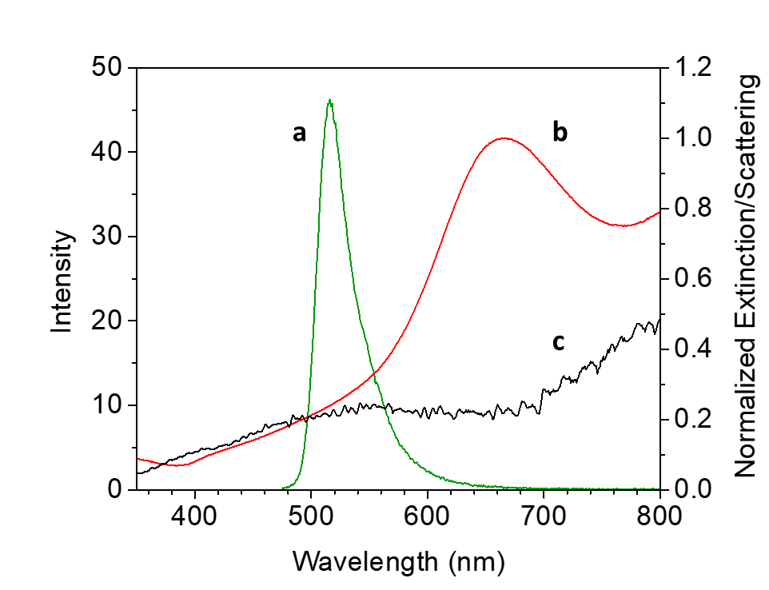
Figure 2. Steady-state fluorescence emission spectrum (a) of 2 (3.2 µM, λ_{Ex} = 460 nm, 20 °C, MeOH, 5 nm excitation slit and emission widths, 625 V PMT); extinction spectrum (b) of AgNP (20 °C, water); synchronous scattering spectrum (c) of AgNP (20 °C, water, λ_{Ex} = λ_{Em}).
All experiments were performed upon thin (70 ± 12 nm) polyvinylpyrrolidone (PVP) films containing randomly distributed molecules of 1 or 2 atop glass substrates. In some cases, the glass substrate had previously been functionalized with a layer of AgNP (details in the Supporting Information). At the bench scale, AgNP increase the steady-state fluorescence emission of 1 and 2 with overall enhancement factors of 2.9 and 3.3, respectively (Figure 3). This result demonstrates that MEF can occur even with limited overlap between the far-field excitation wavelength (488 nm) and the extinction spectrum of AgNP, owing to additional excitation of surface plasmons by the fluorescence emission of the organic dye (Figure 2). The presence of AgNP does not significantly shift the wavelengths of maximum absorption or emission for 1 or 2. Additionally, Figure 3 highlights the general utility of AgNP for fluorescence enhancement of low quantum yield fluorophores. Interestingly, the overall enhancement of 2 is slightly higher than that of 1 despite the intuitive notion that MEF has greater potential to enhance lower quantum yield fluorophores. This result further highlights the desirability of being able to assess and compare the interplay between the two MEF mechanisms for similar dyes. Since the two MEF mechanisms are virtually indistinguishable at the bench scale, we considered the possibility that a single molecule level investigation into the underlying photophysical processes and nano-molecular interactions governing MEF could promote the ability to optimize the design of dye-NP systems for a variety of applications. To this end, we have begun by studying MEF under pragmatic working conditions (e.g. random NP orientation, interparticle spacing and a range of NP-dye distances). For the current study, no attempt was made to control the non-covalent electrostatic associations between AgNP and dyes 1 or 2. Subsequent research may build upon this work by introducing elements of direct control over NP-dye affinity or distance. From a practical perspective, interdisciplinary research seeking to utilize MEF for a variety of applications will also need to contend with some degree of NP polydispersity; even the most advanced NP synthesis techniques (e.g. for atomically precise nanoclusters) typically produce a size and/or shape distribution, which can even be an asset.
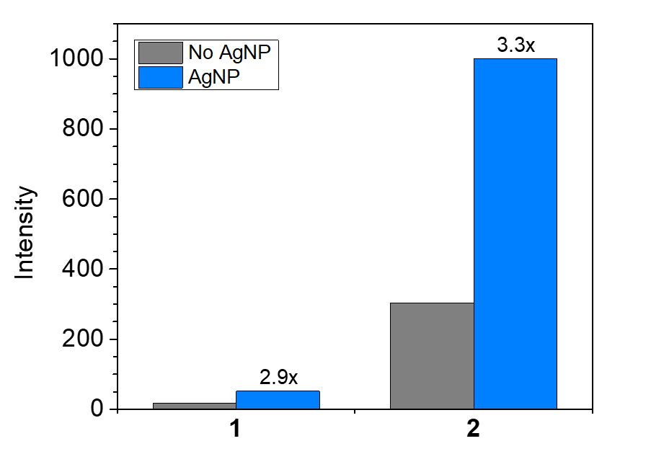
Figure 3. Steady-state fluorescence intensities of thin (70 ± 12 nm) PVP films of 1 or 2 at the emission maximum, in the presence and absence of AgNP, including overall enhancement factors (λ_{Ex} = 490 nm, excitation and emission slit width = 5 nm, PMT voltage = 800 V, 20 °C).
The purpose of the current contribution is to communicate that it is indeed possible to distinguish between the two mechanistic components of MEF using single molecule techniques. While increased fluorophore excitation and plasmophoric MEF are indecipherable at the macroscopic (bench) scale, where only the overall enhancement of the steady-state fluorescence intensity can be detected (Figure 3), the relative contributions of the two mechanisms become readily apparent upon statistical analysis of single molecule fluorescence intensities, often referred to as ‘fluorescence bursting’ or ‘bursts’ (Figure 4). Fluorescence bursting intensities were obtained by monitoring the fluorescence of single molecules over time (Figures S4-S5), using TIRFM (Figure S6). Contrary to our previous study of BODIPY 1, for which the goal was to achieve light-induced, PAG-assisted fluorescence activation, the current investigation is not complicated by the transformation of 1 to 2. Instead, the focus here is on gaining a better grasp of the fundamental processes governing MEF by examining nano-molecular interactions between AgNP and either 1 or 2 separately.
In the absence of AgNP, the intensities of single molecules of 1 (Figure 4A) and 2 (Figure 4B) follow log-normal distributions, which is reasonable given that molecular brightness is the product of the molar extinction coefficient and fluorescence quantum yield. In contrast, normal distributions arise when the independent variable is the sum of a set of random variables.^{53,54} As expected, the higher number of occurrences of fluorescence bursting and slightly greater mean (µ) burst intensity for BODIPY 2 (Table 2) are due to its larger quantum yield of fluorescence (Φ_{F}) and 10% higher molar extinction coefficient (ε) relative to BODIPY 1 (Table 1). Variance in bursting intensity is attributable to a combination of fluorophore distance from the glass-sample interface and heterogeneities inherent to the emission of single molecules (e.g. photobleaching of individual fluorophores). We control for these effects by establishing the single molecule behaviours of 1 and 2 in the absence of AgNP as a baseline for characterization of MEF at the single molecule level. In order to ensure the statistical relevance of these data, five TIRFM image sequences of equal length, recorded at five different randomly selected regions of interest were analyzed for each of the four experimental conditions summarized in Figure 4.
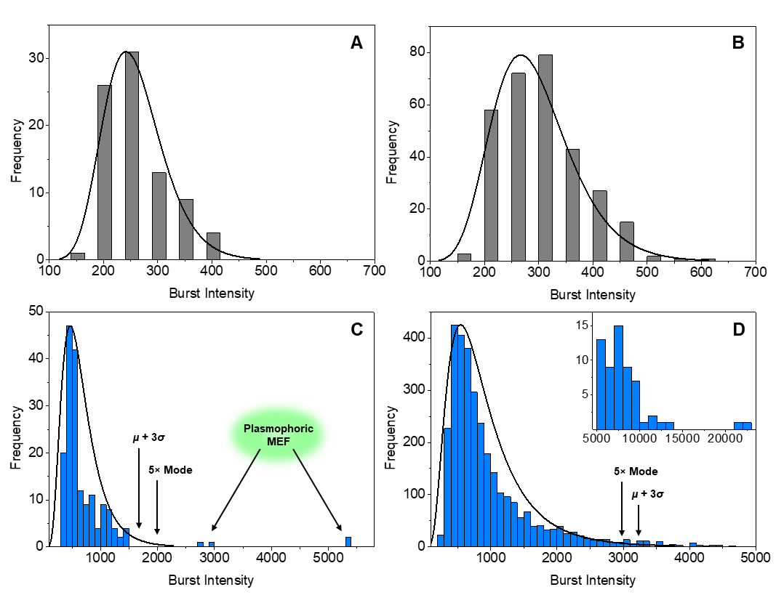
Figure 4. Intensity distributions for single molecule fluorescence bursting events corresponding to species 1 (A) and 2 (B) alone, as well as MEF of 1 (C) and 2 (D) in the presence of AgNP. Representative bursting trajectories are available in the Supporting Information.
Table 2. Summary of single molecule burst analysis of 1 and 2.ª
 | µ | σ | RSD (%) | Number of Bursts
1 | 259 | 57 | 22 | 84
2 | 294 | 76 | 26 | 301
1 + AgNP | 669 | 344 | 51 | 176
2 + AgNP | 1012 | 757 | 75 | 3211
In the presence of AgNP, MEF is immediately evident from a dramatic increase in the number of bursting events for both species and a general shift of the log-normal distribution toward higher intensities (i.e. higher statistical mean and mode). AgNP surface plasmons are well-known to concentrate the surrounding electric field, thereby increasing the rate of excitation for all fluorophores in the vicinity of the AgNP surface.^{9,23,33,41,42} Interestingly, Figure 4 reveals that 1 and 2 are affected differently by the presence of AgNP; a 2-fold increase in the number of bursting events for species 1 (176 events) was eclipsed by a nearly 11-fold increase for species 2 (3211 events). Moreover, the mean fluorescence burst intensity and relative standard deviation (RSD) increase to 669 ± 344 (RSD 51%) for 1 and 1012 ± 757 (RSD 75%) for 2 in the presence of AgNP. This translates to 2.6-fold and 3.4-fold enhancement of mean burst intensity in the presence of AgNP for 1 and 2, respectively. As shown in Table 3, these data establish a critical link between single molecule results and the bench scale enhancement factors in Figure 3. Notice that agreement between the bench scale and single molecule level improves as the number of detected single molecule bursts increases.
Table 3. Comparison of bench scale and single molecule level (µ) enhancement factors.
 | 1 | 2
Bench Scale | 2.9× | 3.3×
Single Molecule | 2.6× | 3.4×
Percent Differenceª | 11% | 3%
ªPercent Difference calculated as the absolute difference between the two enhancement factors, divided by their average.

High relative standard deviations are typical of MEF,^{30,46,55} and are caused by the secondary populations of extraordinarily intense bursts displayed in Figure 4C and Figure 4D. Despite identical experimental conditions (i.e. irradiance, sample thickness, amounts of dye and AgNP), these unmistakable deviations from the log-normal distribution do not occur in equal proportions for 1 and 2, ruling out the possibility that they are simply the result of variance due to NP polydispersity, interparticle distance, dye-NP separation or random dipole orientation. Remarkably, these highly intense bursts illustrate the formation of radiative plasmophores, exhibiting the characteristically higher fluorescence quantum yield associated with dye-NP coupling.^{9,41,42} This result is in good agreement with the plasmophoric and increased fluorophore excitation MEF mechanisms manifesting differently at the single molecule level, where the former causes a shift toward higher burst intensities for both log-normal distributions in the presence of AgNP.
The larger secondary population of high intensity plasmophoric bursts emphasized in Figure 4D (inset) vs. Figure 4C demonstrates that plasmophoric emission accounts for a much higher proportion of the MEF of 2 relative to the plasmophoric component of the MEF of 1 (approximately twice as much, vide infra). Quantitative analysis of this important observation relies upon the ability to definitively separate single molecule fluorescence bursts representing enhanced quantum yield (i.e. plasmophoric emission) from bursts that correspond to an increased rate of fluorophore excitation. This categorization was facilitated by the design of a system of two organic fluorophores with similar chemical structures and near identical absorptivity, for which the only major mechanistic difference in MEF should therefore be related to their respective abilities to couple with AgNP. This comparison provided a visual indication of the approximate intensity threshold for plasmophoric fluorescence bursting. That is, the distinction between the two populations of fluorescence bursts near the tail end of the log-normal distribution is readily apparent in Figure 4C, but becomes blurred as the contribution of the plasmophoric mechanism toward MEF increases (Figure 4D). Therefore, this methodology could potentially be very useful for characterizing MEF of organic dyes exhibiting higher quantum yields, where the plasmophoric mechanism may play a much more prominent role.
In the presence of AgNP, only 2.3% of BODIPY 1 fluorescence bursts are greater than three standard deviations (3σ) more intense than the mean: for BODIPY 2, this value rises to 4.2%. While two to three standard deviations from the mean is generally considered to be sufficient evidence of statistically relevant behaviour, we have incorporated multiple redundancies into our method for segmenting fluorescence bursts into two categories according to the underlying MEF mechanism. Critically, assigning an alternative intensity threshold of five-times the mode resulted in a nearly identical relationship between the contributions of plasmophoric emission toward the MEF of 1 (2.3% of bursts) and 2 (4.4% of bursts). Remarkably, this relationship is maintained upon considering the sum of the peak intensities for all single molecule fluorescence bursts from 1 or 2 in the presence of AgNP. For BODIPY 1, the 2.3% of bursts that correspond to the increased excitation mechanism make up 13% of total single molecule peak burst intensity. It follows that the average 4.3% plasmophoric component of the MEF of 2 should represent approximately 24% of total burst intensity. To our delight, both the µ + 3σ and 5× mode thresholds indeed align with this expectation by translating the 4.3% of bursts categorized as plasmophoric MEF for 2 into 22% and 23% of total burst intensity, respectively (i.e. an average difference of only 6% from the expected value of 24%).
Taken together, our single molecule level analysis indicates that the increased excitation MEF mechanism dominates for both fluorophores, and that the plasmophoric MEF mechanism is approximately twice as prevalent for 2 relative to 1. Given the similar chemical structures, spectral profiles and molar absorptivities of 1 and 2, it is not surprising that they appear to experience approximately the same degree of increased excitation. We also did not observe any significant spectral distortions in the enhanced spectra (Figure S7), which is typical when the increased excitation mechanism is prevalent because free space emission dominates the enhanced emission spectrum.²³ Moreover, our results suggest that 2 is better able to form highly emissive complexes through near-field dipole interactions with AgNP, with NP-dye coupling being roughly twice as efficient for 2 vs. 1. In the formation of such plasmophores through NP-dye coupling, fluorophores can be considered as oscillating dipoles inducing electronic oscillations in the nearby metal NP that in turn impact the fluorophore’s emission.^{9,42} In cases where NP scattering overlaps with fluorophore emission, the quantum yield is increased; if molecular emission primarily overlaps with NP absorption, fluorescence is quenched.^{9,23,42} In both instances, radiative decay by the dye is a pre-requisite. While the radiative decay of 1 is diminished by the existence of an intramolecular charge transfer (ICT) state positioned above the ground state (S₀), which provides a non-radiative pathway for the deactivation of the excited state that is otherwise responsible for the fluorescence of 1, the emission of 2 is not impeded by any such non-radiative decay pathway.⁵² Therefore, the higher quantum yield of 2 with respect to 1 explains its superior ability to induce plasmonic activation through near-field, nano-molecular dipole interactions with AgNP, leading to a greater contribution from the plasmophoric MEF mechanism and ultimately a higher bench scale enhancement factor overall. While ensemble averaged fluorescence enhancement at the bench scale is often thought to be inversely proportional to the fluorescence quantum yield of the dye, some research has suggested that the relationship may be unfounded.^{9,10,24,31,39,44,49} We suggest that this discrepancy may be partially explained by attempts to generalize the comparison of vastly different combinations of organic fluorophores, excitation wavelengths and metal nanoparticles. This work makes a valuable contribution to the understanding of MEF by studying a well-constructed system of two analogous fluorophores at the single molecule level, and provides a concrete example of a situation in which quantum yield of fluorescence is positively correlated with both the contribution of the plasmophoric MEF mechanism and overall fluorescence enhancement.
CONCLUSION
Overall, our experimental results and analysis contribute two key developments toward the ongoing effort to develop a more complete understanding of the nano-molecular interactions involved in MEF. First, the balance between the two mechanistic components of MEF (which is not necessarily equivalent to the overall fluorescence enhancement factor) appears to be sensitive to the fluorescence quantum yield of the organic dye in the low quantum yield regime. Although more work is clearly needed to complete the bigger picture, this observation may be especially relevant when the far-field excitation wavelength does not interact strongly with the nanoparticle extinction spectrum. Here, the greater contribution of plasmophoric MEF and higher overall enhancement of 2 relative to 1, reflects a greater propensity for near-field nano-molecular dipole interactions with AgNP. Mechanistically, an inherently higher photon flux emitted by 2 causes a greater degree of near-field activation of AgNP surface plasmons. At the same time, greater activation of surface plasmons by 2 facilitated complexation between fluorophores and AgNP, thereby increasing the contribution of the plasmophoric mechanism toward overall MEF.
Moreover, we have established a practical method by which single molecule fluorescence microscopy can be used to distinguish the relative contributions of the two mechanistic components of MEF and link that performance back to overall enhancement at the bench scale. In brief, this method consists of examining the distributions of single molecule level fluorescence intensities (i.e. bursts) in the presence and absence of AgNP, then using statistical analysis to categorize bursting events as representative of either the plasmophoric or increased excitation MEF mechanisms. Bursts that fell within a log-normal intensity distribution (also observed in the absence of AgNP) were attributed to increased excitation MEF, while significantly higher intensities were shown to represent nanoparticle-dye coupling corresponding to the plasmophoric MEF mechanism. We validated this technique using multiple intensity thresholds and by establishing a connection between bench scale enhancement factors and behaviour observed at the single molecule level.
This achievement will continue to lead toward a more comprehensive understanding of the photophysical processes governing MEF, ultimately allowing for improved design of hybrid nanoparticle-molecular systems tailored to specific applications. The ability to characterize the relative contributions of increased fluorophore excitation vs. increased quantum yield not only contributes to the scientific body of knowledge by offering fundamental insights into nano-molecular interactions, it is also incredibly valuable upon considering the relative paths toward optimizing MEF for different applications. We envision that the continued study of MEF in different nanoparticle-fluorophore systems at the single molecule level will further expand its utility, through the development of a standardized strategic approach for designing and optimizing nano-molecular systems for a host of applications.

ASSOCIATED CONTENT
Supporting Information. Synthetic protocols, instrumentation, TIRFM experimental details, single molecule image analysis protocol, example single molecule fluorescence bursting plots, absorption and emission spectra, electron microscopy, nanoparticle size distribution, diagram of experimental design, example TIRFM video.
The following files are available free of charge.
Supporting Information (PDF)
Supporting Video (.avi)
AUTHOR INFORMATION
Notes
The authors declare no competing financial interests.
ACKNOWLEDGMENT
We thank the Natural Sciences and Engineering Research Council of Canada (Discovery Grant) and Ryerson University (start-up funds) for supporting this research program. This work has also been supported by the Ryerson University Faculty of Science Dean’s Research Fund. N. P. Dogantzis acknowledges the receipt of a Ryerson University Graduate Scholarship and an Ontario Graduate Scholarship. We thank Denis Alexandre Therien and Prof. François Lagugné-Labarthet (Western University) for advice and support.
REFERENCES
(1) Goldberg, J. M.; Wang, F.; Sessler, C. D.; Vogler, N. W.; Zhang, D. Y.; Loucks, W. H.; Tzounopoulos, T.; Lippard, S. J. Photoactivatable Sensors for Detecting Mobile Zinc. J. Am. Chem. Soc. 2018, 140, 2020–2023. https://doi.org/10.1021/jacs.7b12766.
(2) Grenier, V.; Walker, A. S.; Miller, E. W. A Small-Molecule Photoactivatable Optical Sensor of Transmembrane Potential. J. Am. Chem. Soc. 2015, 137, 10894–10897. https://doi.org/10.1021/jacs.5b05538.
(3) Wu, P. J.; Chen, J. L.; Chen, C. P.; Chan, Y. H. Photoactivated Ratiometric Copper(II) Ion Sensing with Semiconducting Polymer Dots. Chem. Commun. 2013, 49, 898–900. https://doi.org/10.1039/c2cc37848e.
(4) Wysocki, L. M.; Lavis, L. D. Advances in the Chemistry of Small Molecule Fluorescent Probes. Curr. Opin. Chem. Biol. 2011, 15, 752–759. https://doi.org/10.1016/j.cbpa.2011.10.013.
(5) Fothergill, S. M.; Joyce, C.; Xie, F. Metal Enhanced Fluorescence Biosensing: From Ultra-Violet towards Second near-Infrared Window. Nanoscale 2018, 10, 20914–20929. https://doi.org/10.1039/c8nr06156d.
(6) Deng, W.; Xie, F.; Baltar, H. T. M. C. M.; Goldys, E. M. Metal-Enhanced Fluorescence in the Life Sciences: Here, Now and Beyond. Phys. Chem. Chem. Phys. 2013, 15, 15695–15708. https://doi.org/10.1039/c3cp50206f.
(7) Lasgow, G. G.; Sers, S. R. Surface-Enhanced Raman Scattering (SERS) and Resonance Raman Scattering (SERRS): A Review of Applications. Appl. Spectrosc. 2011, 65, 825–837. https://doi.org/10.1366/11-06365.
(8) Nagy-Simon, T.; Potara, M.; Craciun, A.; Licarete, E.; Astilean, S. IR780-Dye Loaded Gold Nanoparticles as New near Infrared Activatable Nanotheranostic Agents for Simultaneous Photodynamic and Photothermal Therapy and Intracellular Tracking by Surface Enhanced Resonant Raman Scattering Imaging. J. Colloid Interface Sci. 2018, 517, 239–250. https://doi.org/10.1016/j.jcis.2018.02.007.
(9) Lakowicz, J. R. Principles of Fluorescence Spectroscopy; Springer, New York, 2006. https://doi.org/10.1007/978-0-387-46312-4.
(10) Lakowicz, J. R. Radiative Decay Engineering: Biophysical and Biomedical Applications. Anal. Biochem. 2001, 24, 1–24. https://doi.org/10.1006/abio.2001.5377.
(11) Lakowicz, J. R. Plasmonics in Biology and Plasmon-Controlled Fluorescence. Plasmonics 2006, 1, 5–33. https://doi.org/10.1007/s11468-005-9002-3.
(12) Hwang, K.; Wu, P.; Kim, T.; Lei, L.; Tian, S.; Wang, Y.; Lu, Y. Photocaged DNAzymes as a General Method for Sensing Metal Ions in Living Cells. Angew. Chemie - Int. Ed. 2014, 53, 13798–13802. https://doi.org/10.1002/anie.201408333.
(13) Kozma, E.; Kele, P. Fluorogenic Probes for Super-Resolution Microscopy. Org. Biomol. Chem. 2019, 17, 215–233. https://doi.org/10.1039/c8ob02711k.
(14) Li, H.; Vaughan, J. C. Switchable Fluorophores for Single-Molecule Localization Microscopy. Chem. Rev. 2018, 118, 9412–9454. https://doi.org/10.1021/acs.chemrev.7b00767.
(15) Li, W. H.; Zheng, G. Photoactivatable Fluorophores and Techniques for Biological Imaging Applications. Photochem. Photobiol. Sci. 2012, 11, 460–471. https://doi.org/10.1039/c2pp05342j.
(16) Puliti, D.; Warther, D.; Orange, C.; Specht, A.; Goeldner, M. Small Photoactivatable Molecules for Controlled Fluorescence Activation in Living Cells. Bioorganic Med. Chem. 2011, 19, 1023–1029. https://doi.org/10.1016/j.bmc.2010.07.011.
(17) Raymo, F. M. Photoactivatable Synthetic Fluorophores. Phys. Chem. Chem. Phys. 2013, 15, 14840–14850. https://doi.org/10.1039/c3cp51822a.
(18) Raymo, F. M. Photoactivatable Synthetic Dyes for Fluorescence Imaging at the Nanoscale. J. Phys. Chem. Lett. 2012, 3, 2379–2385. https://doi.org/10.1021/jz301021e.
(19) Wang, L.; Frei, M. S.; Salim, A.; Johnsson, K. Small-Molecule Fluorescent Probes for Live-Cell Super-Resolution Microscopy. J. Am. Chem. Soc. 2019, 141, 2770–2781. https://doi.org/10.1021/jacs.8b11134.
(20) Lee, R.; Bae, J.; Qin, C.; Lee, H.; Jae, B.; Young, G. Synthesis of Therminol-Based Plasmonic Nanofluids with Core/Shell Nanoparticles and Characterization of Their Absorption/Scattering Coefficients. Sol. Energy Mater. Sol. Cells 2020, 209, 110442. https://doi.org/10.1016/j.solmat.2020.110442.
(21) Sriram, P.; Manikandan, A.; Chuang, F.; Chueh, Y. Hybridizing Plasmonic Materials with 2D-Transition Metal Dichalcogenides toward Functional Applications. Small 2020, 16, 1904271. https://doi.org/10.1002/smll.201904271.
(22) Knoblauch, R.; Ra, E.; Geddes, C. D. Heavy Carbon Nanodots 2: Plasmon Amplification in Quanta Platet Wells and the Correlation with the Synchronous Scattering Spectrum. Phys. Chem. Chem. Phys. 2019, 21, 1254–1259. https://doi.org/10.1039/C8CP06299D.
(23) Knoblauch, R.; Hamo, H. Ben; Marks, R.; Geddes, C. D. Spectral Distortions in Metal-Enhanced Fluorescence: Experimental Evidence for Ultra-Fast and Slow Transitions. J. Phys. Chem. C 2020, 124, 4723–4737. https://doi.org/10.1021/acs.jpcc.9b11055.
(24) Wang, Y.; Horacek, M.; Zijlstra, P. Strong Plasmon Enhancement of the Saturation Photon Count Rate of Single Molecules. J. Phys. Chem. Lett. 2020, 11, 1962–1969. https://doi.org/10.1021/acs.jpclett.0c00155.
(25) Zhang, M.-X.; You, E.-M.; Zheng, P.; Ding, S.-Y.; Tian, Z.-Q.; Moskovits, M. Accurately Predicting the Radiation Enhancement Factor in Plasmonic Optical Antenna Emitters. J. Phys. Chem. Lett. 2020, 11, 1947–1953. https://doi.org/10.1021/acs.jpclett.0c00304.
(26) Krishna, K. H.; Sreekanth, K. V; Strangi, G. Dye-Embedded and Nanopatterned Hyperbolic Metamaterials for Spontaneous Emission Rate Enhancement. J. Opt. Soc. Am. B 2016, 33, 1038–1043. https://doi.org/10.1364/JOSAB.33.001038.
(27) Kinoshita, T. K.; Nguyen, D. Q. N.; Nishino, T. N.; Nakao, H. N.; Shiigi, H. S.; Nagaoka, T. N. Fluorescence Enhancement of Nanoraspberry Hot-Spot Source Composed of Gold Nanoparticles and Aniline Oligomers. Anal. Sci. 2015, 31, 487–493. https://doi.org/10.2116/analsci.31.487.
(28) Kochuveedu, S. T.; Kim, D. H. Surface Plasmon Resonance Mediated Photoluminescence Properties of Nanostructured Multicomponent Fluorophore Systems. Nanoscale 2014, 6, 4966–4984. https://doi.org/10.1039/c4nr00241e.
(29) Lin, H. H.; Chen, I. C. Study of the Interaction between Gold Nanoparticles and Rose Bengal Fluorophores with Silica Spacers by Time-Resolved Fluorescence Spectroscopy. J. Phys. Chem. C 2015, 119, 26663–26671. https://doi.org/10.1021/acs.jpcc.5b08477.
(30) Dogantzis, N. P.; Hodgson, G. K.; Impellizzeri, S. Optical Writing and Single Molecule Reading of Photoactivatable and Silver Nanoparticle-Enhanced Fluorescence. Nanoscale Adv. 2020, 2, 1956–1966. https://doi.org/10.1039/d0na00049c.
(31) Dragan, A. I.; Geddes, C. D. Wavelength-Dependent Metal-Enhanced Fluorescence Using Synchronous Spectral Analysis. Chem. Phys. Lett. 2013, 556, 168–172. https://doi.org/10.1016/j.cplett.2012.11.035.
(32) Dragan, A. I.; Geddes, C. D. Excitation Volumetric Effects (EVE) in Metal-Enhanced Fluorescence. Phys. Chem. Chem. Phys. 2011, 13, 3831–3838. https://doi.org/10.1039/c0cp01986k.
(33) Geddes, C. D.; Lakowicz, J. R. Editorial: Metal-Enhanced Fluorescence. J. Fluoresc. 2002, 12, 121–129. https://doi.org/10.1023/A:1016875709579.
(34) Klimov, V. V.; Ducloy, M.; Letokhov, V. S. Spontaneous Emission of an Atom in the Presence of Nanobodies. Quantum Electron. 2001, 31, 569–586. https://doi.org/10.1070/qe2001v031n07abeh002007.
(35) Messinger, B. J.; Von Raben, K. U.; Chang, R. K.; Barber, P. W. Local Fields at the Surface of Noble-Metal Microspheres. Phys. Rev. B 1981, 24, 649–657. https://doi.org/10.1103/PhysRevB.24.649.
(36) Fort, E.; Grésillon, S. Surface Enhanced Fluorescence. J. Phys. D. Appl. Phys. 2008, 41, 013001. https://doi.org/10.1088/0022-3727/41/1/013001.
(37) Aslan, K.; Leonenko, Z.; Lakowicz, J. R.; Geddes, C. D. Annealed Silver-Island Films for Applications in Metal-Enhanced Fluorescence: Interpretation in Terms of Radiating Plasmons. J. Fluoresc. 2005, 15, 643–654. https://doi.org/10.1007/s10895-005-2970-z.
(38) Gryczynski, I.; Malicka, J.; Gryczynski, Z.; Lakowicz, J. R. Radiative Decay Engineering 4. Experimental Studies of Surface Plasmon-Coupled Directional Emission. Anal. Biochem. 2004, 324, 170–182. https://doi.org/10.1016/j.ab.2003.09.036.
(39) Lakowicz, J. R.; Shen, Y.; D’Auria, S.; Malicka, J.; Fang, J.; Gryczynski, Z.; Gryczynski, I. Radiative Decay Engineering 2. Effects of Silver Island Films on Fluorescence Intensity, Lifetimes, and Resonance Energy Transfer. Anal. Biochem. 2002, 277, 261–277. https://doi.org/10.1006/abio.2001.5503.
(40) Lakowicz, J. R. Radiative Decay Engineering 3. Surface Plasmon-Coupled Directional Emission. Anal. Biochem. 2004, 324, 153–169. https://doi.org/10.1016/j.ab.2003.09.039.
(41) Lakowicz, J. R. Radiative Decay Engineering 5: Metal-Enhanced Fluorescence and Plasmon Emission. Anal. Biochem. 2005, 337, 171–194. https://doi.org/10.1016/j.ab.2004.11.026.
(42) Lakowicz, J. R.; Ray, K.; Chowdhury, M.; Szmacinski, H.; Fu, Y.; Zhang, J.; Nowaczyk, K. Plasmon-Controlled Fluorescence: A New Paradigm in Fluorescence Spectroscopy. Analyst 2008, 133, 1308–1346. https://doi.org/10.1039/b802918k.
(43) Lakowicz, J. R.; Malicka, J.; Gryczynski, I.; Gryczynski, Z.; Geddes, C. D. Radiative Decay Engineering: The Role of Photonic Mode Density in Biotechnology. J. Phys. D. Appl. Phys. 2003, 36, 240–249. https://doi.org/10.1088/0022-3727/36/14/203.
(44) Xie, F.; Centeno, A.; Ryan, M. R.; Riley, D. J.; Alford, N. M. Au Nanostructures by Colloidal Lithography: From Quenching to Extensive Fluorescence Enhancement. J. Mater. Chem. B 2013, 1, 536–543. https://doi.org/10.1039/c2tb00278g.
(45) Xie, F.; Baker, M. S.; Goldys, E. M. Enhanced Fluorescence Detection on Homogeneous Gold Colloid Self-Assembled Monolayer Substrates. Chem. Mater. 2008, 20, 1788–1797. https://doi.org/10.1021/cm703121m.
(46) Choudhury, S. D.; Badugu, R.; Ray, K.; Lakowicz, J. R. Silver − Gold Nanocomposite Substrates for Metal-Enhanced Fluorescence: Ensemble and Single-Molecule Spectroscopic Studies. J. Phys. Chem. C 2012, 116, 5042–5048.
(47) Anger, P.; Bharadwaj, P.; Novotny, L. Enhancement and Quenching of Single-Molecule Fluorescence. Phys. Rev. Lett. 2006, 96, 113002. https://doi.org/10.1103/PhysRevLett.96.113002.
(48) Wei, L. Y.; Huang, K. S.; Lin, H. H.; Wu, Y. P.; Tan, K. T.; Lee, Y. Y.; Chen, I. C. Kinetic Mechanism of Metal Enhanced Fluorescence by Gold Nanoparticle with Avidin-Biotin as Spacer and by Gold-Silver Core-Shell Nanoparticle Using Fluorescence Lifetime Image Microscopy. J. Phys. Chem. C 2018, 122, 28431–28438. https://doi.org/10.1021/acs.jpcc.8b10440.
(49) Dragan, A. I.; Geddes, C. D. Metal-Enhanced Fluorescence: The Role of Quantum Yield ,Q₀, in Enhanced Fluorescence. Appl. Phys. Lett. 2012, 100, 093115.
(50) Chowdhury, M. H.; Aslan, K.; Malyn, S. N.; Lakowicz, J. R.; Geddes, C. D. Metal-Enhanced Chemiluminescence. J. Fluoresc. 2006, 16, 295–299. https://doi.org/10.1007/s10895-006-0082-z.
(51) Kee, H. L.; Kirmaier, C.; Yu, L.; Thamyongkit, P.; Youngblood, W. J.; Calder, M. E.; Ramos, L.; Noll, B. C.; Bocian, D. F.; Scheidt, W. R. et al. Structural Control of the Photodynamics of Boron-Dipyrrin Complexes. J. Phys. Chem. B 2005, 109, 20433-20443. https://doi.org/10.1021/jp0525078.
(52) Shaban Ragab, S.; Swaminathan, S.; Deniz, E.; Captain, B.; Raymo, F. M. Fluorescence Photoactivation by Ligand Exchange around the Boron Center of a BODIPY Chromophore. Org. Lett. 2013, 15, 3154–3157. https://doi.org/10.1021/ol401380n.
(53) Limpert, E.; Stahel, W. A.; Abbt, M. Log-Normal Distributions across the Sciences: Keys and Clues. Bioscience 2001, 51, 341–352. https://doi.org/10.1641/0006-3568(2001)051[0341:LNDATS]2.0.CO;2.
(54) Burstein, E. A.; Emelyanenko, V. Log-Normal Description of Fluorescence Spectra of Organic Fluorophores. Photochem. Photobiol. 1996, 64, 316–320. https://doi.org/10.1111/j.1751-1097.1996.tb02464.x.
(55) Fu, Y.; Zhang, J.; Lakowicz, J. R. Plasmonic Enhancement of Single-Molecule Fluorescence Near a Silver Nanoparticle. J. Fluoresc. 2007, 17, 811–816. https://doi.org/10.1007/s10895-007-0259-0.

TOC Graphic

