Sentiment Analysis

Joy Girgis Wahby
500908864
SOC 540
Eva Jewell
November 28, 2021

The water crisis has been an ongoing issue for years on the First Nations reserves due to the lack of empathy from the government. Water is an important part of Indigenous culture that represents the source of life from the Earth, so when the water is undrinkable and unclean this creates a problematic situation for not only Indigenous land but Indigenous culture as a whole. This paper will discuss the concern regarding the pipelines within Indigenous communities that causes leaks within the flow of the clean drinking water on the reserves. Based on this critical issue I will be focusing on negative sentiments regarding the water crisis, and create counter narratives of the sociopolitical imaginaries in response to the sentiments.
In watching the Global News video “The News Reality: Why are some First Nations still without clean drinking water?”, the video discusses the ongoing water crisis. It was very disturbing to hear and see the treatment of First Nations reserves because of how the government was apathetic towards Indigenous peoples. In the video a woman says how all she wants is clean drinking water and she feels that the government sees Indigenous peoples as less than human. Another person in the video explains how this has been a problem for over 26 years, which goes to show how Indigenous communities needs are not met, or taken seriously. In the article “Dirty Water, Dirty Secrets”, the author reminds readers that “Water is life...We believe water is a human right and all people should have access to clean and affordable water.” (Vowel, 2016, p.214).
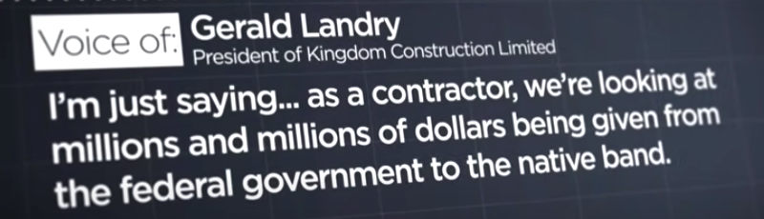
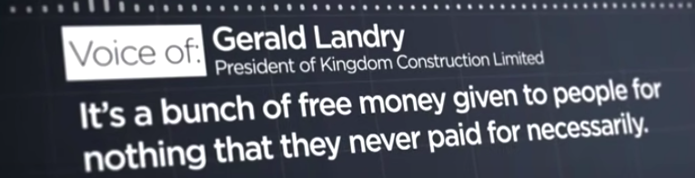
Through a qualitative approach I will analyze a few comments that stood out to me from the Global News YouTube video. Under the YouTube video that I am analyzing, there are many negative sentiments that have been commented which come off as ignorant and apathetic. A comment that was left on the YouTube video was from the user Dustin who said, “Why are the community members themselves not doing somthing about it. Start a fundraiser, sell the naming rights, take control of your own future. Apperently any government of any stripe is too unreliable to do it for you.” (Dustin, 2021). This is a negative sentiment as it comes off very ignorant to not see that this is an issue that comes from the government and not from Indigenous peoples. Not only were there negative sentiments coming from comments, but there were some even in the video coming from an apathetic contractor, Gerald Landry. Landry states how the money that is given to Indigenous communities are “given to people for nothing they never paid for necessarily.”. This goes to show that this is a negative and insensitive sentiment towards Indigenous peoples and the water crisis that they go through on the reserves.

Overall there were only a handful of positive sentiments that came off as empathetic towards the Indigenous communities struggling with the water crisis. One of the positive sentiments came from the user TNP’R sheepdog saying how, “​​Clean water should be a necessity for all people of every nation, this is a world wide occurring problem that we should not still have.” (TNP’R sheepdog, 2021). This was a positive sentiment as the commenter understood that there was a critical issue and a violation of a basic human right that was still unresolved.
In analyzing the comments that were produced in relation to the video, I believe that most of the comments were negative. Of the negative sentiments, the mythologies that are present are that the water crisis is not as big of a deal as it is shown to be, that Indigenous people have the money or can come up with the money and that people living on the reserve can fix this issue, not the government. Having such negative sentiments come from people who are not fully aware of the situation the Indigenous communities are going through, makes their contribution apathetic rather than empathetic. Of the positive sentiments that were commented on the video, I believe that their contribution towards the Indigenous community came from an empathetic and supportive place due to the frustration of the negative and neglectful treatment Indigenous peoples received from the government.
According to Million in the Meissner (2017) article, sociopolitical imaginaries are practices that are made up of discourses surrounding the knowledge of certain groups, events, or experiences. In response to sociopolitical imaginaries a counter narrative to the mythology of First Nations peoples being wasteful or lazy is that First Nations peoples are humans who struggle to be accepted and acknowledged for their land and their culture. In accepting Indigenous peoples we need to acknowledge the water crisis because not only does it affect Indigenous culture but Indigenous feminism. According to McGregor (2013), “Many women have taken up the role of speaking and caring for water, thus renewing their traditional responsibilities” (McGregor, 2013, p.74). In Indigenous communities women have a responsibility in caring for the water, as they have a connection with the water being the source of life and from the earth. This is important as a counter narrative because due to having unclean drinking water this creates a bigger issue as it affects their daily lives. Therefore in the mythology that Indigenous peoples are responsible for this water crisis, the counter narrative is that the government is responsible as they build pipelines on their land which causes leaks in their clean water source creating unclean drinking water.
To conclude, my experience in reading all these comments posted on the water crisis was very emotional. This is because I am a very empathetic person and believe everyone deserves their voices heard and their basic human rights, so to see how there are many negative comments that are not supportive at all upsets me. Indigenous peoples are human and need their basic necessities of survival, the fact that this has been an ongoing issue that has been discussed several times, that the reserves are in need of clean drinking water, makes me very frustrated that there is no change. As Miller mentions in the Global News article, “racism is embedded in some outdated federal policies that have deprived many First Nations of clean drinking water.” (Souza, 2021). I think what needs to be done for non-Indigenous peoples to better understand the lives and challenges of First Nations people is research, and attentiveness. Reading and listening to the felt experiences of Indigenous peoples with an open mind and empathetic heart allows for steps to be taken in seeing change. Proactive activism rather than slacktivism creates a direction for the future of Indigenous communities to receive recognition about their experience and their truth.

References
Global News. (2021, February 20) The New Reality: Why are some First Nations still without
clean drinking water? [Video] YouTube. https://youtu.be/a5zYtIwMJ2Y
McGregor, D. (2013). Indigenous Women, Water Justice and Zaagidowin (Love). Canadian
Woman Studies, 30(2), 71-78.
Meissner, S.N. (2017). Therapeutic nations: Healing in an age of indigenous human rights (book
review). The American Philosophical Association Newsletter, 16 (2), 14-17.
Souza, M. D. (2021, September 9). How colonial systems have left some First Nations without
drinking water. Global News. Retrieved November 29, 2021, from https://globalnews.ca/news/7643288/broken-promises-first-nations/.
Vowel, C. (2016). Chapter 24: “Dirty water, dirty secrets: Drinking water in First Nations
communities.” In Indigenous writes: A guide to First Nations, Métis, and Inuit issues in Canada (pp. 213-222). Winnipeg: Highwater Press.

